**ROLL NO:20AD051 ASSIGNMENT: 1 DATE:04/06/2023**

**QUESTION 1:**

**QUERY FOR CREATING TABLE**:

CREATE TABLE BOOKSDB(

BOOK_TITLE VARCHAR(50),

AUTHOR VARCHAR(30),

GENRE VARCHAR(50),

PUBLICATION_YEAR INT,

PRICE INT

);

INSERT INTO BOOKSDB VALUES("WINGS OF FIRE","APJ","AUTOBIOGRAPHY",2002,200);

INSERT INTO BOOKSDB VALUES("WONDERFUL DAY","JAMES","STORY",2010,210);

INSERT INTO BOOKSDB VALUES("GOOD THINGS","WILLIAMS","BIOGRAPHY",2011,150);

INSERT INTO BOOKSDB VALUES("LIVE YOUR LIFE","DANNY","SUPPLEMENTARY",2002,200);

INSERT INTO BOOKSDB VALUES("KAMBARAMAYANAM","KAMBAR","BIOGRAPHY",200,120);

1. **RETERIVE ALL BOOKS:**

SELECT*FROM BOOKSDB;

**OUTPUT:**

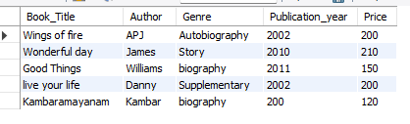

1. **QUERY FOR PRINTING BOOKS TITLE:**

SELECT BOOK_TITLE FROM BOOKSDB;

**OUTPUT:**



1. **QUERY FOR UPDATING PRICE IN A TABLE:**

UPDATE BOOKSDB SET PRICE=300 WHERE BOOK_TITLE="WINGS OF FIRE";

SELECT*FROM BOOKSDB;

**OUTPUT:**

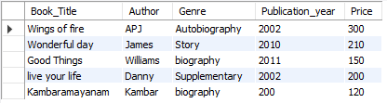

1. **QUERY FOR DELETING TABLE:**

DELETE FROM BOOKSDB WHERE BOOK_TITLE="GOOD THINGS";

SELECT*FROM BOOKSDB;

**OUTPUT:**

